DRAFT

Proposed Real Estate Development Model (REDM) for SANDAG

By Michael Clay

March 5, 2020

**Introduction**

This document summarizes the proposed real estate development model (REDM) for implementation as part of the larger SRF SANDAG modeling system. The data flow for this model is presented in Figure 1 and the model flow chart is presented in Figure 2. This model is based, in part, on the floorspace supply module of the Real Estate Market Model (REMM) currently in place in the Salt Lake City, Utah, metropolitan area. The Wasatch Front Regional Council (WFRC), Mountainland Association of Governments (MAG), and the Utah Department of Transportation collaborated with Urban Planning International LLC across a five year period to develop REMM. This collaboration included in-depth interviews with real estate professionals who advised on the model structure, processes, conceptual relationships, variables, and coefficients that play a role for them in their professional practices and should be included in the model. Throughout this process, careful attention was payed to the “behavioral realism” of the model—or how well it represented the actual real estate development process. These professionals included real estate financiers (both residential and commercial), bankers, residential builders, commercial builders, realtors, land speculators, large land holders, and commercial leasing agents.

**Economic Underpinnings**

Real estate development at the regional or metropolitan level is based upon the profit principle. Evaluation of the costs of bring products to market compared with the expected returns or prices those products can be sold or leased for, determine what will or will not be built. Local land policy as a constraint determines what types of products can be considered at each location/parcel. It is commonly accepted that a minimum expected 25% profit/return on investment is required for a residential or commercial product to be brought to market. So, a realistic determination of developability by real estate product type, by location is:

(cost of land + cost of construction) + 25% ≤ expected price

Equation 1: Determination of profitability

These four basic elements—cost of land, cost of construction, expected price, and local policy constraints—will be discussed individually.

Cost of Land

Cost of land or land price is one of the most influential variables in the local real estate development process. The cost of land varies spatially and temporally. Land price is available from multiple sources at varying qualities, including county assessors and real estate trade publications. The initial version of REDM will account for spatial variation in land price but not temporal—this can be addressed in future updates with a spatially sensitive, hedonic land cost model.

Cost of Construction

Development construction costs represent the non-land costs of development such as materials, equipment, and labor required to physically construct each real estate product by type. These costs can shift spatially (generally based upon the density of existing development surrounding the parcel under consideration) and from green field development to redevelopment projects. For redevelopment projects, an added demolition cost must be included in the above equation. Demolition costs, like construction costs are affected by the density of products surrounding the parcel under consideration and the quantity of developed floorspace on the parcel itself. Construction costs by product type were obtained from local developers in the REMM model. These estimates can be used as a starting place for REDM with some calibration until actual construction costs can be obtained from local developers.

Expected Price

This is the expected price the developer anticipates receiving for the development and varies by real estate product type and by location. Data for this variable will be derived from the bidding process in the household and employment location choice/bid-rent submodule. REDM will evaluate prices in previous years’ auctions (averaging the previous three years of simulated auction/bid-rent) at the TAZ level and uses that value to determine what products are economically viable, by location, in the current simulation year. For the initial modeled years, actual MLS sales values will be used to generate starting values of expected price by real estate product type by location.

Local Policy Constraints

Local land use policy controls the types of real estate products, and intensity with which they can be developed, at the parcel level. SANDAG already has this data in the GPALL and CAPACITY submodules. In the initial version of REDM these constraints will be modeled as binding. Future model improvements could allow sufficient economic pressure to overcome these constraints, if desired—this approach has been used elsewhere with some success.

**Model Logic**

Each legal land parcel will undergo a series of evaluations in every simulated year. REDM will be fed a GIS layer that is populated with all of the data in Figure 1. Any parcels that will not be available for development or redevelopment at any point in the simulated time period will be identified as nonbuildable prior to REDM operations. These parcels might be deemed nonbuildable for a variety of reasons and examples might include civic buildings, parks, roads, sports arenas, religious structures, etc.

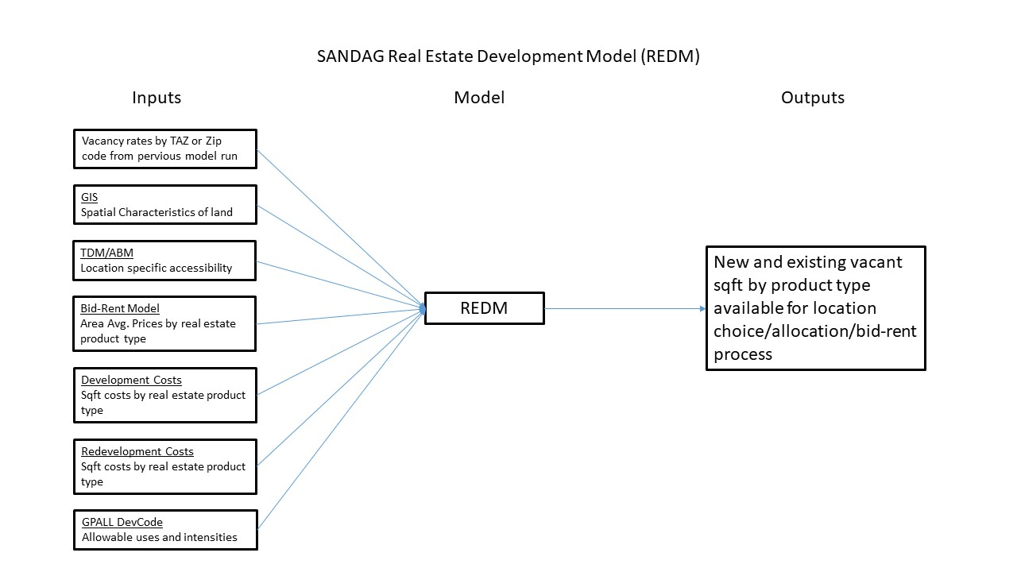Figure 1: REDM Data Flow

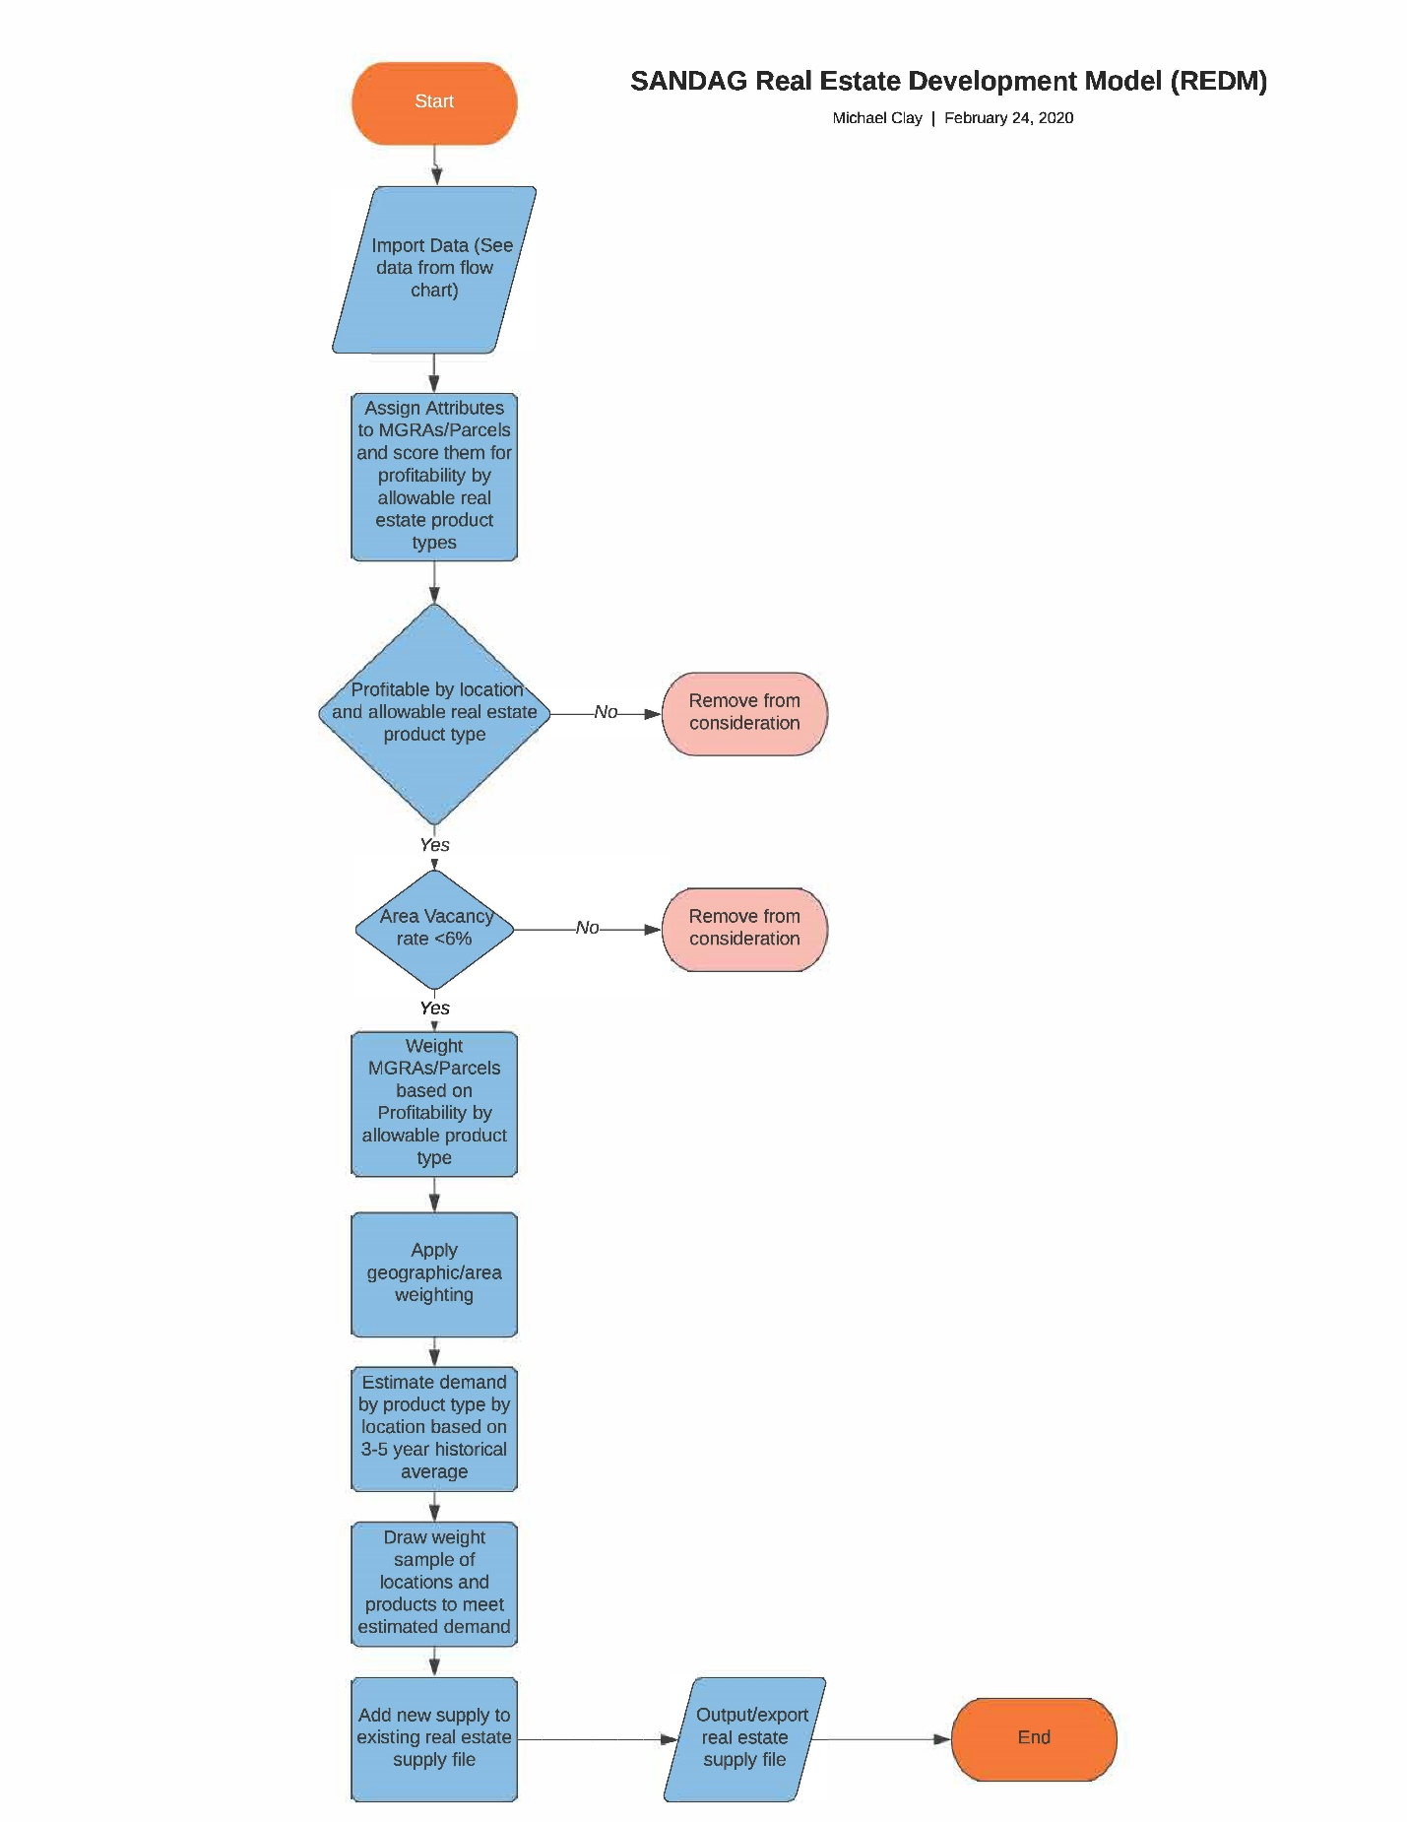

Figure 2: REDM Flow Chart